**MAT1011 – Calculus for Engineers (MATLAB), Fall Semester 2020-2021**

**Digital Assignment SL. 4, Experiment – 2b: Laplace transforms, Inverse Laplace Transforms.**

**By: Jonathan Rufus Samuel (20BCT0332) Date: 28.11.2020**

__________________________________________________________________________________

**Q1.1) Find the Laplace transform of the function: f(t) = 1 + 2√t + 3/√t**

A: Code is as follows:

%Find the Laplace transform of the function: f(t) = 1 + 2√t + 3/√t

clear all

clc

syms t

x = input('Enter a function in terms of t: ');

y = laplace(x);

disp('The Laplace transform of f(t) is: ');

disp(y);

Output (via Command Window):

Enter a function in terms of t:

1 + 2*sqrt(t) + 3/sqrt(t)

The Laplace transform of f(t) is:   
1/s + (3*pi^(1/2))/s^(1/2) + pi^(1/2)/s^(3/2)

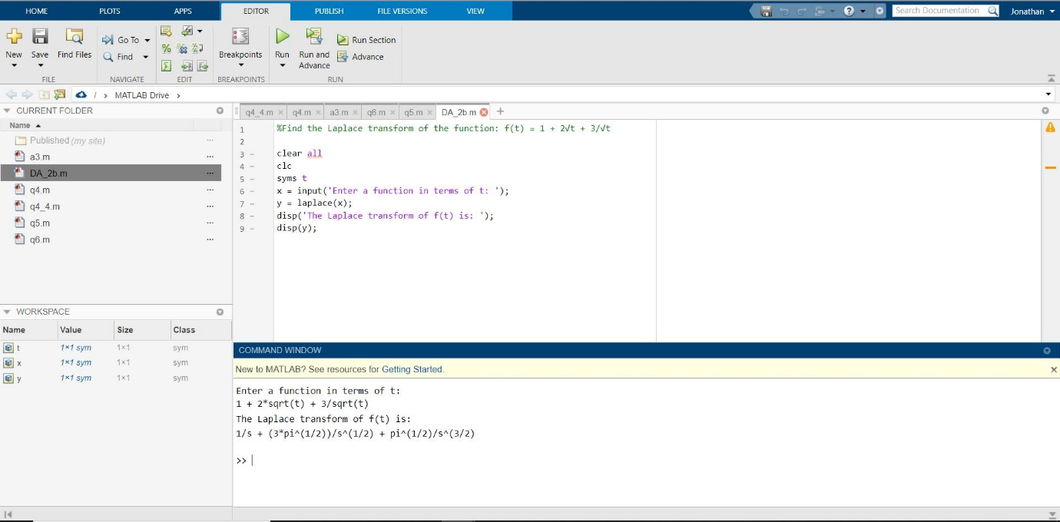

**Q1.2) Find the Laplace transform of the function: f(t) = (cos2t-cos3t)/t**

A: Code is as follows:

%Find the Laplace transform of the function: f(t) = (cos2t-cos3t)/t

clear all

clc

syms t

x = input('Enter a function in terms of t: ');

y = laplace(x);

disp('The Laplace transform of f(t) is: ');

disp(y);

Output (via Command Window):

Enter a function in terms of t:

(cos(2*t)-cos(3*t))/t

The Laplace transform of f(t) is:   
log(9/s^2 + 1)/2 - log(4/s^2 + 1)/2

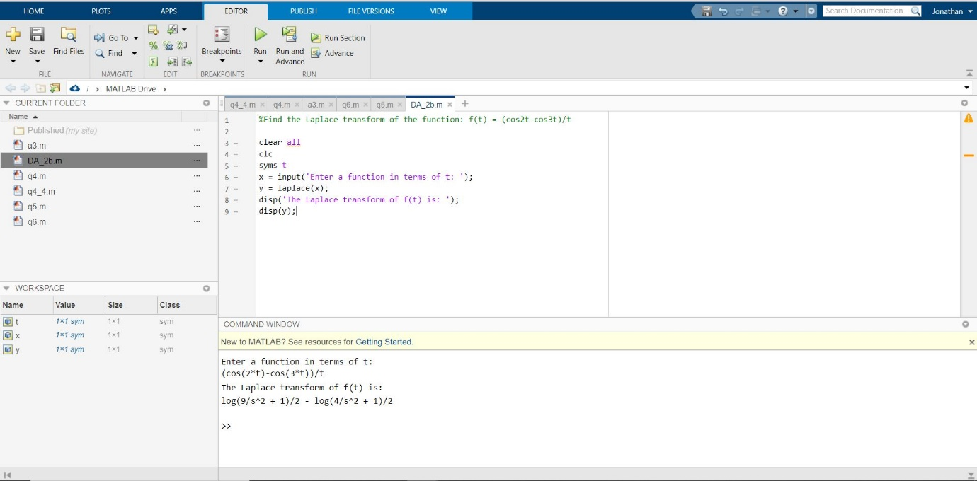

**Q2.1) Find the inverse Laplace transform of the function: f(s) = 6/(s^2+2s-8)**

A: Code is as follows:

%Find the inverse Laplace transform of the function: f(s) = 6/(s^2+2s-8)

clear all

clc

syms s

s = input('Enter a function in terms of s: ');

t = ilaplace(s);

disp('The Inverse Laplace transform of f(s) is: ');

disp(t);

Output (via Command Window):

Enter a function in terms of s:

6/(s^2+2*s-8)

The Inverse Laplace transform of f(s) is:   
exp(2*t) - exp(-4*t)

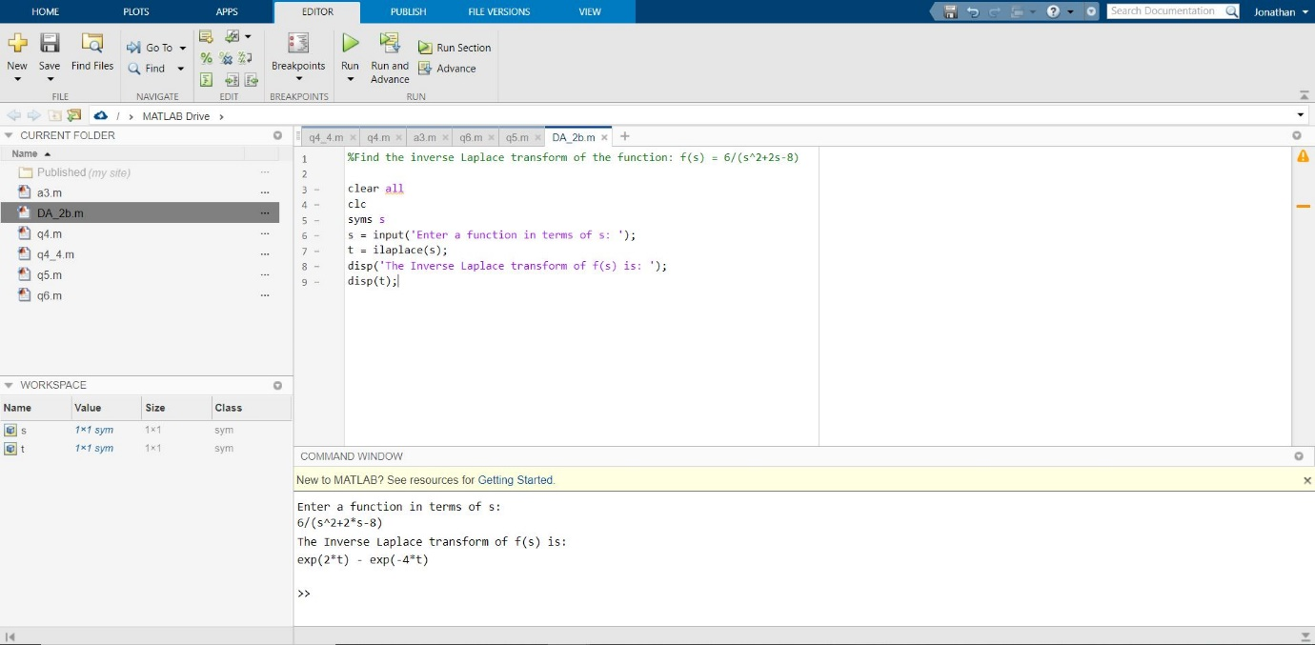

**Q2.2) Find the inverse Laplace transform of the function: f(s) = 4s+5/(((s-1)^2)*(s+2))**

A: Code is as follows:

%Find the inverse Laplace transform of the function:

% f(s) = ((4*s)+5)/(((s-1)^2)*(s+2))

clear all

clc

syms s

s = input('Enter a function in terms of s: ');

t = ilaplace(s);

disp('The Inverse Laplace transform of f(s) is: ');

disp(t);

Output (via Command Window):

Enter a function in terms of s:

((4*s)+5)/(((s-1)^2)*(s+2))

The Inverse Laplace transform of f(s) is:   
exp(t)/3 - exp(-2*t)/3 + 3*t*exp(t)

